Project Management Review Summary – Grainger PLC

Project | End of Tenancy
Period | 15th – 22nd Nov 2023
Status Overview | Sprint 4: Build
Progress in the last week | Item |  | Completed | Responsible
Progress in the last week | Sprint 3 UAT Feedback |  | 17th Nov | Grainger
Progress in the last week | Review of Production Deployment dates |  | 21st Nov | Grainger / Open Box
Upcoming deliverables / feedback required | Item | Due | Responsible | Status
Upcoming deliverables / feedback required | Go-Live Preparation | WIP | Grainger | Change Management, Training, Support
Upcoming deliverables / feedback required | Demo | 1st Dec | Grainger / Open Box | On Track
Upcoming deliverables / feedback required | End-to-End UAT | 4th Dec | Grainger | Completed by 15th Dec
Upcoming deliverables / feedback required | Steerco #2 | 5th Dec | Grainger / Open Box | Date to be confirmed
Upcoming deliverables / feedback required | Go-Live | 15th Jan 2024 | Grainger / Open Box | On Track
Discussions/Risks /Issues | - Backlog items will be pulled in to sprint 4 time allows.  - 271 story points are currently allocated to the project. The initial backlog was 185 story points.  - Planning for support beyond post go-live hypercare (e.g. Open Box 0.5 FTE)  - Jira Licenses have expired (reached out to Jaic) for the dashboard so these have not been updated.
Personnel Notes | - Jacob on leave in December.  - Open Box will be taking extended leave over December.

Sprint Metrics
Dashboard can be located here
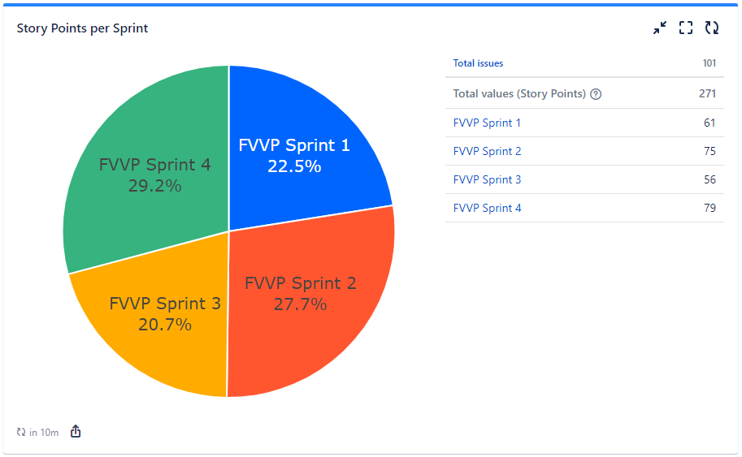
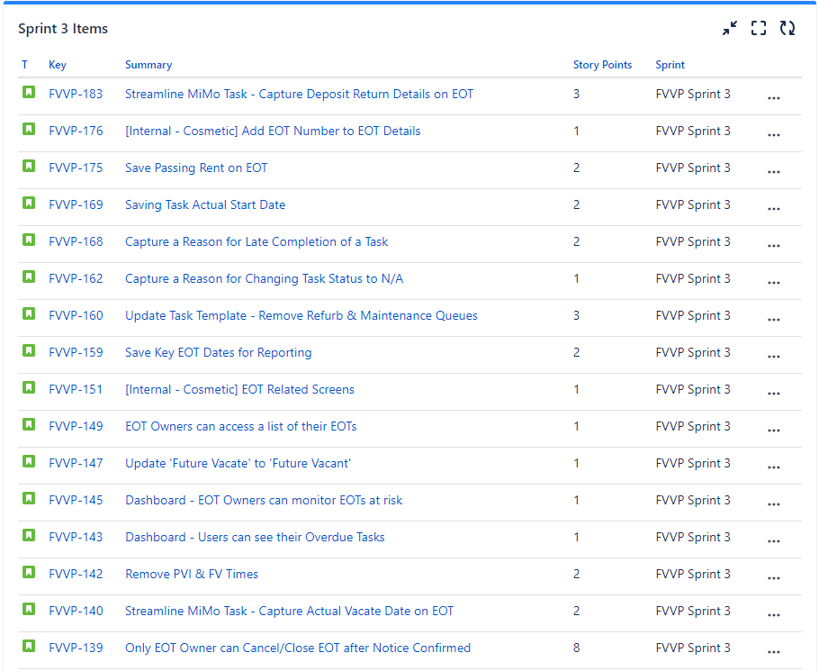
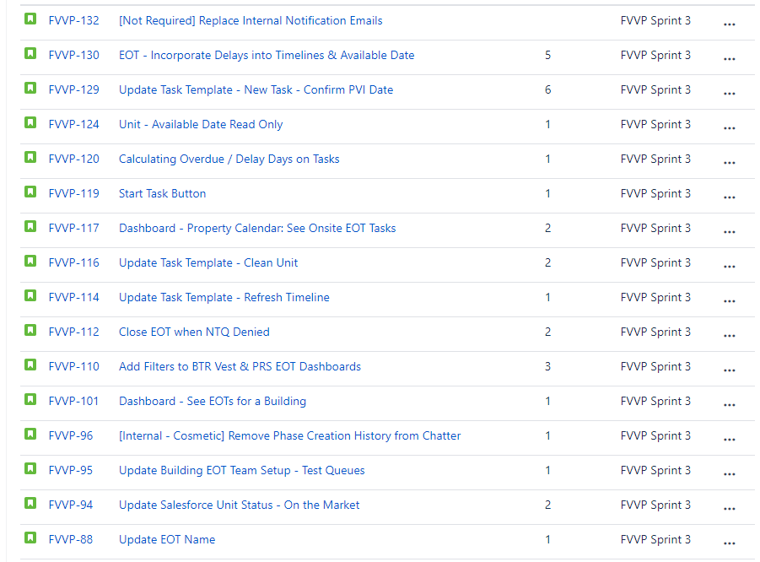
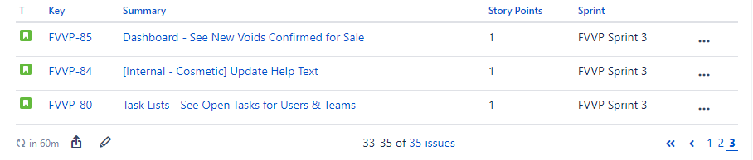
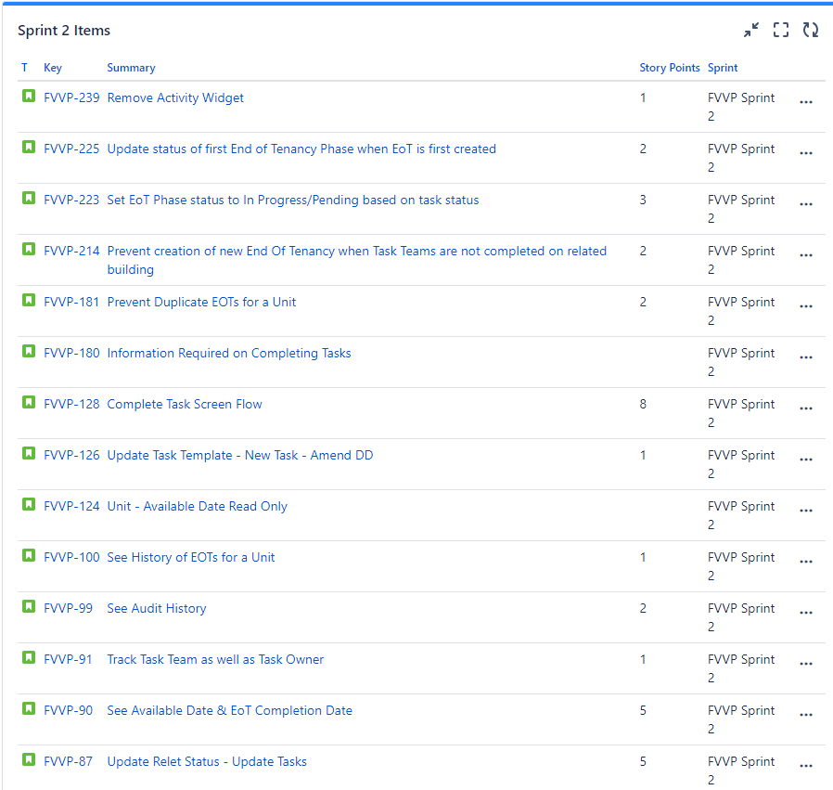

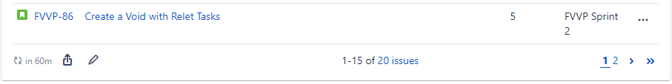
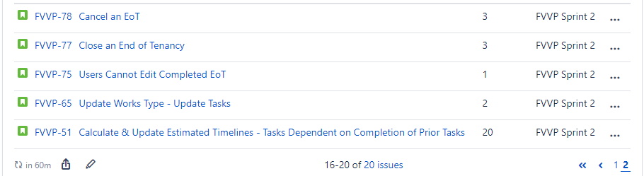
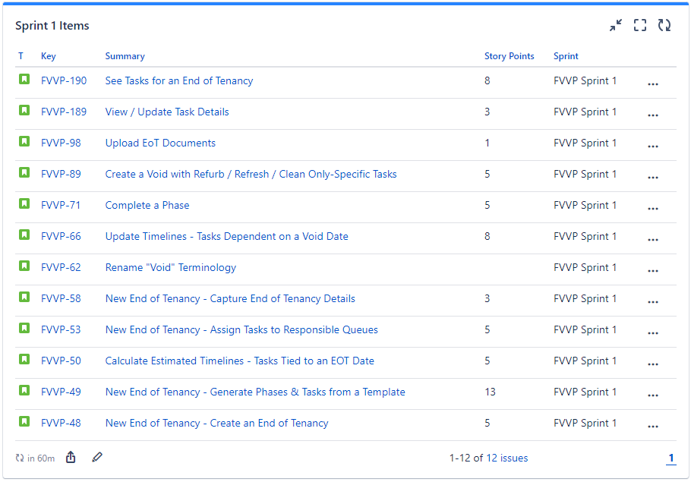
Initial Backlog

Summary | Issue key | Story Points
Calculate void duration | FVVP-197
See Tasks for a Void | FVVP-190 | 8
View / Update Task Details | FVVP-189 | 3
Replace Internal Notification Emails | FVVP-132 | 2
Reporting - See Teams with High Number of Tasks | FVVP-127 | 1
Dashboard - See Active Voids Behind Schedule | FVVP-125 | 2
Property Calendar - See Onsite Void Tasks | FVVP-117 | 1
Detailed Tasks - Close Down Tenancy | FVVP-116 | 2
Detailed Tasks - Deposit Release | FVVP-115 | 2
Detailed Tasks - Finalize Check Out | FVVP-114 | 2
Detailed Tasks - Review Check Out | FVVP-113 | 2
Detailed Tasks - Check Property Condition | FVVP-112 | 2
Detailed Tasks - Check Out | FVVP-111 | 2
Detailed Tasks - Book Works | FVVP-110 | 2
Detailed Tasks - Cancel Direct Debit | FVVP-109 | 2
Detailed Tasks - Check Compliance | FVVP-108 | 2
Detailed Tasks - Notify Stakeholders | FVVP-107 | 2
Detailed Tasks - Validate Required Information is Captured | FVVP-106 | 2
Detailed Tasks - Confirm Notice | FVVP-105 | 2
Detailed Tasks - Validate Notice | FVVP-104 | 2
See Active Voids for a Building | FVVP-101 | 1
See History of Voids on a Unit | FVVP-100 | 1
See Void & Task Audit History | FVVP-99 | 1
Upload Void Documents | FVVP-98 | 1
See Unit View Arrangements & Key Location | FVVP-97 | 2
Update Salesforce Unit - Keep Available Date Up-to-Date | FVVP-96 | 2
Update Salesforce Unit - Keep FV Date Up-to-Date | FVVP-95 | 2
Update Salesforce Unit - Keep Unit Status Up-to-Date | FVVP-94 | 5
Update Salesforce Unit - New Void | FVVP-92 | 5
See Estimated Available Date & Void Completion Date | FVVP-90 | 5
Create a Void with Refurb / Refresh / Clean Only-Specific Tasks | FVVP-89 | 5
Update Relet Status - Update Tasks | FVVP-87 | 5
Create a Void with Relet Tasks | FVVP-86 | 5
Dashboard - See New Voids Confirmed for Sale | FVVP-85 | 1
New Void - Default Unit Sale Status from Salesforce | FVVP-84 | 1
Dashboard - Other KPIs for R1 | FVVP-82 | 10
Dashboard - See Open Tasks | FVVP-80 | 2
Cancel a Void | FVVP-78 | 1
Close a Void | FVVP-77 | 3
See Summary of Void Phases & % Completion | FVVP-76 | 3
Complete Voids are Read-Only | FVVP-75
Dashboard - KPI: Vacant Days | FVVP-72
Complete a Phase | FVVP-71 | 5
Update Timelines - Tasks Dependent on a Void Date | FVVP-66 | 8
Update Void Works Type - Update Tasks | FVVP-65
Update Timelines - Tasks Dependent on Completion of Prior Tasks | FVVP-64 | 13
Detailed Tasks - PVI | FVVP-63
Rename "Void" Terminology | FVVP-62
Set Tasks to Not Applicable [Close] | FVVP-61 | 1
Capture a Reason for Updating Key Void Information | FVVP-59 | 3
New End of Tenancy - Capture End of Tenancy Details | FVVP-58 | 3
See Salesforce Unit & Building Attributes in a Void | FVVP-57 | 1
New Void - Calculate Estimated PVI Date | FVVP-56 | 3
Data Migration - Void Queues | FVVP-54 | 3
New End of Tenancy - Assign Tasks to Responsible Queues | FVVP-53 | 5
Calculate Estimated Timelines - Tasks Dependent on Completion of Prior Tasks | FVVP-51 | 13
Calculate Estimated Timelines - Tasks Tied to an EOT Date | FVVP-50 | 5
New End of Tenancy - Generate Phases & Tasks from a Template | FVVP-49 | 13
New End of Tenancy - Create an End of Tenancy | FVVP-48 | 5
 |  | 185

Historical Reports

Project | End of Tenancy
Period | 08th – 15th Nov 2023
Status Overview | Sprint 3: UAT  Sprint 4: Build
Progress in the last week | Item |  | Completed | Responsible
Progress in the last week | Feedback on Sprint 4 items |  | 10th Nov | Grainger
Progress in the last week | Sprint 3 Demo |  | 10th Nov | Open Box
Upcoming deliverables / feedback required | Item | Due | Responsible | Status
Upcoming deliverables / feedback required | Sprint 3 UAT Feedback | 17th Nov | Grainger | WIP
Upcoming deliverables / feedback required | Go-Live Preparation | WIP | Grainger | Change Management, Training, Support
Upcoming deliverables / feedback required | End-to-End UAT | 4th Dec | Grainger | Completed by 15th Dec
Upcoming deliverables / feedback required | Steerco #2 | 5th Dec | Grainger / Open Box | Date to be confirmed
Upcoming deliverables / feedback required | Go-Live | January 2024 | Grainger / Open Box | Date to be confirmed
Discussions/Risks /Issues | - 271 story points are currently allocated to the project. The initial backlog was 185 story points.  - Planning for support beyond post go-live hypercare (e.g. Open Box 0.5 FTE)
Personnel Notes | - Jacob on leave in December.  - Open Box will be taking extended leave over December.

Project | End of Tenancy
Period | 2nd – 08th Nov 2023
Status Overview | Sprint 3: Build
Progress in the last week | Item |  | Completed | Responsible
Progress in the last week | Change Management Plan Discussion |  | 1st Nov | Grainger / Open Box
Upcoming deliverables / feedback required | Item | Due | Responsible | Status
Upcoming deliverables / feedback required | Feedback on Sprint 4 items | 10th Nov | Grainger | On Track
Upcoming deliverables / feedback required | Sprint 3 Demo | 10th Nov | Open Box | On Track
Upcoming deliverables / feedback required | Sprint 3 UAT Feedback | 17th Nov | Grainger | 1 week from 10th Nov
Upcoming deliverables / feedback required | Go-Live Preparation | WIP | Grainger | Change Management, Training, Support
Upcoming deliverables / feedback required | End-to-End UAT | 4th Dec | Grainger | Completed by 15th Dec
Upcoming deliverables / feedback required | Go-Live | January 2024 | Grainger / Open Box | On Track
Discussions/Risks /Issues | - 251 story points are currently allocated to the project. The initial backlog was 185 story points.  - Sprint 4 is likely to have fewer user stories (points) due to the progress made in sprints 1,2 & 3. We are also reserving some capacity to handle feedback from Sprint 3 & regression test the timeline calculations.
Personnel Notes | - Open Box will be taking extended leave over December.

Project | End of Tenancy
Period | 25th Oct – 2 Nov 2023
Status Overview | Sprint 3: Build
Progress in the last week | Item |  | Completed | Responsible
Progress in the last week | Reporting feedback ahead of the Mon refinement session |  | 27th Oct | Grainger
Progress in the last week | Sprint 2 UAT feedback |  | 27th Oct | Grainger
Progress in the last week | Call to discuss change management strategy |  | 2nd Nov | Open Box
Progress in the last week | Steerco Presentation |  | 2nd Nov | Grainger / Open Box
Upcoming deliverables / feedback required | Item | Due | Responsible | Status
Upcoming deliverables / feedback required | Sprint 3 Demo | 10th Nov | Open Box | On Track
Upcoming deliverables / feedback required | Sprint 3 UAT | 17th Nov | Grainger | 1 week from 10th Nov
Upcoming deliverables / feedback required | Change Management Plan | TBC | Grainger | Open Box to assist Grainger in determining feasible change management process
Discussions/Risks /Issues | - 242 story points are currently allocated to the project. The initial backlog was 185 story points.  - Sprint 4 is likely to have fewer user stories (points) due to the progress made in sprints 1,2 & 3. We are also reserving some capacity to handle feedback from Sprint 3.  - Planning required for January ‘24 go-live, training and support.
Personnel Notes | - None

Project | End of Tenancy - Implementation
Period | 3rd – 10th Oct
Status Overview | Sprint 2: Build
Progress in the last week | Item |  | Completed | Responsible
Progress in the last week | Sprint 1 UAT |  | 6th Oct | Grainger
Progress in the last week | New QA/UAT environment (Staging) refreshed from Prod |  | 9th Oct | Open Box
Upcoming deliverables / feedback required | Item | Due | Responsible | Status
Upcoming deliverables / feedback required | Incorporate additional user stories in Sprint 2 | 13th Oct | Open Box | On Track
Upcoming deliverables / feedback required | Sprint 2 UAT (in Staging) | 23rd Oct | Grainger | 1 week in duration  Sprint 1 UAT bugs will also be made available for retest
Discussions/Risks /Issues | - 128 story points currently allocated to sprint 1 & 2. Initial backlog was 185 story points.
Personnel Notes | - Shaun out next week.

Project | End of Tenancy - Implementation
Period | 27th Sep – 3rd Oct
Status Overview | Sprint 1: UAT  Sprint 2: Build
Progress in the last week | Item |  | Completed | Responsible
Progress in the last week | Sprint 1 Demo |  | 2nd Oct | Grainger / Open Box
Progress in the last week | Refinement |  | 3rd Oct | Grainger / Open Box
Upcoming deliverables / feedback required | Item | Due | Responsible | Status
Upcoming deliverables / feedback required | Sprint 1 UAT | 6th Oct | Grainger | On Track
Discussions/Risks /Issues | - Open Box will work with Grainger to see what additional user stories can be brought into sprint 2.
Personnel Notes | - Sam travelling Thu and Fri this week.

Project | End of Tenancy - Implementation
Period | 20th – 27th Sep
Status Overview | Sprint 1 in progress
Progress in the last week | Item |  | Completed | Responsible
Progress in the last week | Realignment on User Stories for Sprint 1 |  | 22nd Sep | Open Box
Progress in the last week | Onboarding of new Open Box team members |  | 22nd Sep | Grainger / Open Box
Upcoming deliverables / feedback required | Item | Due | Responsible | Status
Upcoming deliverables / feedback required | Sprint 1 Demo | 2nd Oct | Grainger / Open Box | Rescheduled to align with Sam’s visit
Upcoming deliverables / feedback required | Refinement | 3rd Oct | Grainger / Open Box | Rescheduled to align with Sam’s visit
Upcoming deliverables / feedback required | Sprint 1 UAT | 2nd Oct | Grainger | 1 week
Discussions/Risks /Issues | - As mentioned in our sprint ceremonies, sprint 1 required a lot of foundational work / effort. As a result, some user stories may roll over to sprint 2. This is not anticipated to have an impact on project cost or timelines.
Personnel Notes | - Sam will be in the Grainger office from Oct 2nd.

Project | End of Tenancy - Implementation
Period | 5th – 20th Sep
Status Overview | Sprint 1 in progress
Progress in the last week | Item |  | Completed | Responsible
Progress in the last week | Project kick-off meeting |  | 5th Sep | Grainger / Open Box
Progress in the last week | Confirmation of sprint ceremonies |  | 9th Sep | Grainger / Open Box
Progress in the last week | Confirmation of Purchase Order |  | 8th Sep | Grainger
Progress in the last week | Fine-tuning Jira |  | 14th Sep | Grainger / Open Box
Upcoming deliverables / feedback required | Item | Due | Responsible | Status
Upcoming deliverables / feedback required | Sprint 1 Demo | 2nd Oct | Grainger / Open Box | Rescheduled to align with Sam’s visit
Upcoming deliverables / feedback required | Refinement | 3rd Oct | Grainger / Open Box | Rescheduled to align with Sam’s visit
Upcoming deliverables / feedback required | Sprint 1 UAT | 2nd Oct | Grainger | 1 week
Discussions/Risks /Issues | - Open Box is reviewing items in sprint 1 & 2 to ensure dependencies will not impact our velocity. This will result in some cards moving between sprint 1 & 2.
Personnel Notes | - Holiday in South Africa on Monday 25th September

